JOINING REPORT

To,

Hexaware Technologies Ltd.,

Dear Sir,

This has reference to your appointment order dated ____18 January 2024____ and I hereby join duties on ______18 January 2024___________

Thanking you.

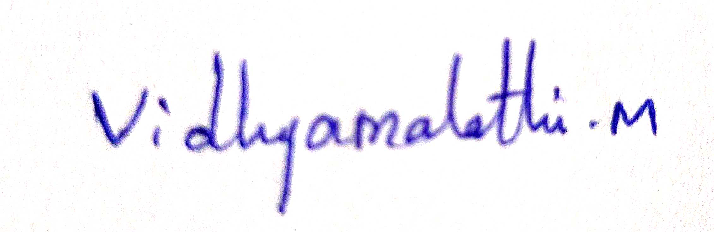

(Name & Signature)

CONFIDENTIALITY AGREEMENT

I,_____Vidhyamalathi M ________ currently residing at ____Coimbatore_______________
____________________________________with permanent residence at, ___________
______________Coimbatore__________________, this _____18____ day of __January_____ (month), ____2024___(year), having been employed/retained by Hexaware Technologies Ltd., (hereinafter referred to as Hexaware) having its registered office at 152 Millennium Business Park, TTC Industrial Area, Sector –3, A Block, Mahape, Navi Mumbai 400701, from ___18 January 2024_____ (date of joining /retaining), agree to the following terms:

During and after my employment/engagement with Hexaware, I will not disclose or use any knowledge or information of an unpublished, confidential, proprietary, or trade secret nature generated or otherwise acquired by me from Hexaware or its customers. During and after my employment with Hexaware, I will keep all such knowledge and information confidential.

At the conclusion of my employment / engagement with Hexaware, or on demand at any time during my employment / engagement, I will immediately return to Hexaware any drawings, writings, prints, documents, computer media, samples, prototypes, parts, or anything else containing, embodying, or disclosing any of Hexaware’s or its customer’s unpublished, confidential, proprietary, or trade secret information that are in my possession or subject to my control. I understand that all such materials, whether generated by me or by others, shall at all times remain property of Hexaware or its customers.

I understand that unauthorized disclosure or use of Hexaware’s or its customer’s unpublished confidential, proprietary, or trade secret information is likely to cause irreparable harm to Hexaware or its customers. I agree that Hexaware or its customers shall be entitled to, individually or jointly, an injunction restraining such unauthorized use of disclosure without (i) proof or irreparable harm or (ii) posting an injunction bond.

The failure of Hexaware to exercise its rights under or insist upon strict performance of the provision of the Agreement shall not operate as a waiver thereof or preclude Hexaware from exercising its rights.


Signature:

Print Name: Vidhyamalathi M

Date:17-12-2023

Place: Coimbatore

Witness (1): Witness (2):
Signature: Signature:

Name: Name:
Address: Hexaware Technologies Ltd., Address:
Date : Date :

